[ Insert official UPAEP logo ]
UPAEP · Decanato de Ingenierías
EVIDENCE — US19-T6
Display anomalies to the producer
SmartGreenAI: Cilantro Crop

1. Task information
Task ID | US19-T6
User Story | US-19 — Identify unusual environmental measurements
Sprint | Sprint 3 (2026-10-12 – 2026-10-30)
Week | Week 2
Responsible | Alexis Enrique Valle Parra
Peer reviewer | Jorge Velez Delgado
Planned / actual hours | 1 h / 1 h
Completed on | October 23, 2026
Status | Done

2. Task description
Show an anomaly badge on the sensor card and a list of recent anomalies with a short explanation in plain language.

3. Completion conditions
✓ Condition 1: Badge visible on the affected sensor.
How it was verified: The badge is visible on the affected sensor card.
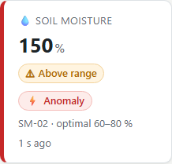
Figure US19-T6-1. Sensor card of SM-02 with the "Anomaly" badge. (US19-T6_Display_Anomalies_Producer_1.png)
✓ Condition 2: Anomaly list shows type and explanation.
How it was verified: The list of recent anomalies shows the type and the explanation.
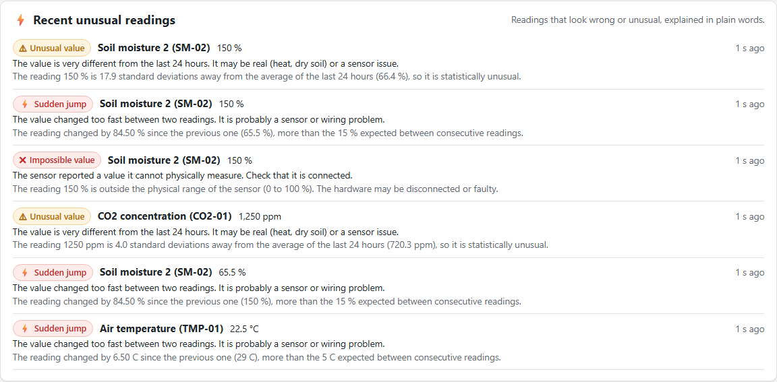
Figure US19-T6-2. Recent unusual readings: type, sensor, value, time, plain-language advice and the technical explanation. (US19-T6_Display_Anomalies_Producer_2.png)
✓ Condition 3: Text understandable by a non-technical user.
How it was verified: Each entry starts with a sentence a non-technical user can act on (for example "The sensor reported a value it cannot physically measure. Check that it is connected."), followed by the technical detail.
Text shown in the panel
⚡ Recent unusual readings
Readings that look wrong or unusual, explained in plain words.
⚠
Unusual value
Soil moisture 2 (SM-02)
150 %
1 s ago
The value is very different from the last 24 hours. It may be real (heat, dry soil) or a sensor issue.
The reading 150 % is 17.9 standard deviations away from the average of the last 24 hours (66.4 %), so it is statistically unusual.
⚡
Sudden jump
Soil moisture 2 (SM-02)
150 %
1 s ago

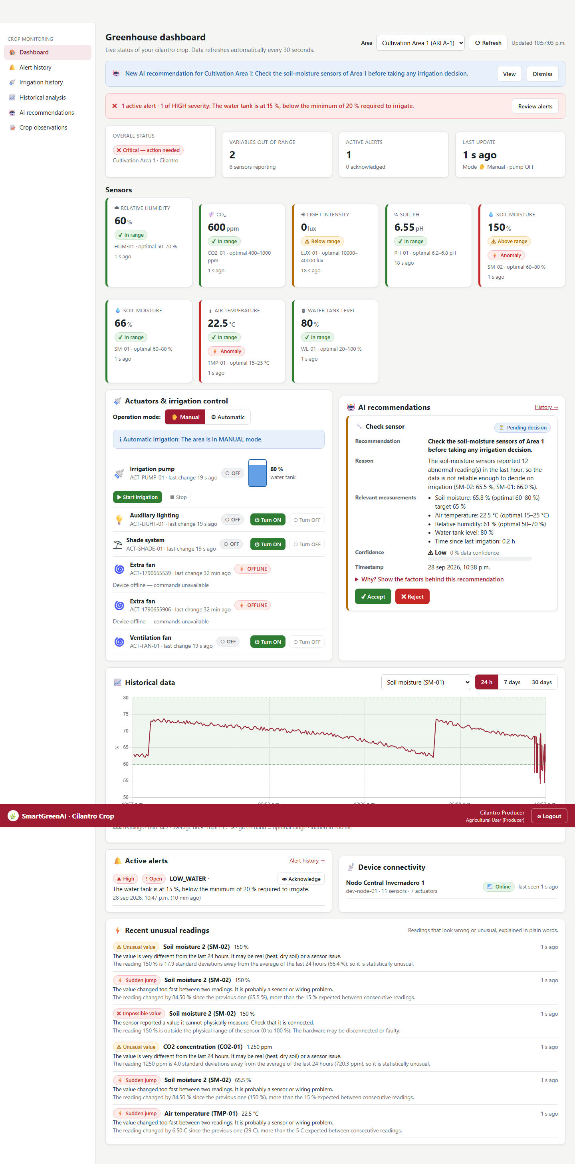
Figure US19-T6-3. Dashboard with the anomaly badge and the list. (US19-T6_Display_Anomalies_Producer_3.png)
✓ Condition 4: Evidence: Screenshot of the dashboard with anomalies.
How it was verified: Screenshot of the dashboard with anomalies.

4. Attached files
- US19-T6_Display_Anomalies_Producer_1.png
- US19-T6_Display_Anomalies_Producer_2.png
- US19-T6_Display_Anomalies_Producer_3.png

5. Traceability
Related requirements | FR-27, NFR-08
Implementation | dashboard anomaly badge and red ✖ markers on the chart (charts.js scatter series); GET /anomalies
Verification | e2e/dashboard.spec.js

6. Sign-off
Role | Name | Date | Signature
Responsible | Alexis Enrique Valle Parra | October 23, 2026
Peer reviewer | Jorge Velez Delgado | October 23, 2026
Product Owner acceptance | Alexis Enrique Valle Parra | October 23, 2026
Approval record: Daily Meeting 3 of Sprint 3 (Monday, October 26, 2026), team update, Alexis Enrique Valle Parra: "Finished US19-T6: anomaly badge and list with a short explanation on the sensor cards." Daily Meeting 3 of Sprint 3 (Monday, October 26, 2026), Scrum board: "Tasks moved to Done last week: US11-T3, US11-T4, US11-T5, US12-T2, US13-T3, US15-T6, US15-T7, US16-T3, US16-T4, US17-T2, US19-T4, US19-T5, US19-T6."

